P 7 Configuring EtherChannel
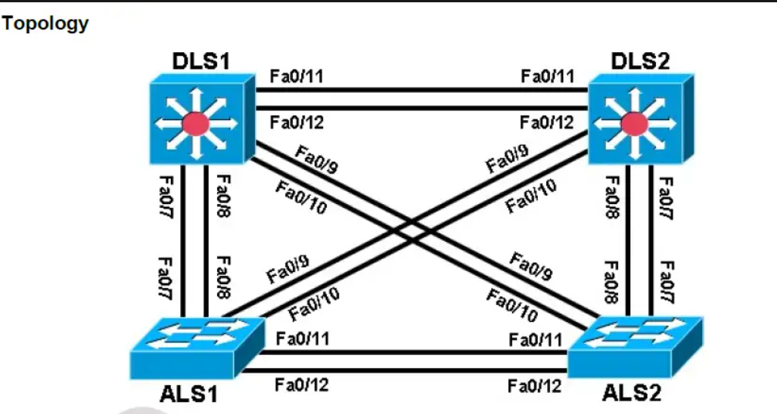

Background
Four switches have just been installed. The distribution layer switches are Catalyst 3560 switches, and the
access layer switches are Catalyst 2960 switches. There are redundant uplinks between the access layer and
distribution layer. Usually, only one of these links could be used; otherwise, a bridging loop might occur.
However, using only one link utilizes only half of the available bandwidth. EtherChannel allows up to eight
redundant links to be bundled together into one logical link.

Required Resources
• 2 switches (Cisco 2960 with the Cisco IOS Release 12.2(46)SE C2960-LANBASEK9-M image or
comparable)
• 2 switches (Cisco 3560 with the Cisco IOS Release 12.2(46)SE C3560- ADVIPSERVICESK9-M
image or comparable)
• Ethernet and console cables

Step 1: Prepare the switches for the lab and Configure basic switch parameters.

DLS1# configure terminal
Enter configuration commands, one per line. End with CNTL/Z.
DLS1(config)# interface range fastEthernet 0/7 - 12
DLS1(config-if-range)# switchport trunk encapsulation dot1q
DLS1(config-if-range)# switchport mode trunk

Step 3: Configure an EtherChannel with Cisco PAgP.

ALS1# show interfaces trunk
ALS1(config)# interface range fastEthernet 0/11 - 12
ALS1(config-if-range)# channel-group 1 mode desirable
Creating a port-channel interface Port-channel 1
ALS1(config)# interface port-channel 1
ALS1(config-if)# switchport mode trunk
ALS1# show etherchannel summary

ALS2(config)# interface range fastEthernet 0/11 - 12
ALS2(config-if-range)# channel-group 1 mode desirable
Creating a port-channel interface Port-channel 1
ALS2(config)# interface port-channel 1
ALS2(config-if)# switchport mode trunk
ALS2# show etherchannel summary

ALS1# show interfaces trunk
ALS1# show spanning-tree

Step 4: Configure an 802.3ad LACP EtherChannel.

ALS1(config)# interface range fastEthernet 0/7 - 8
ALS1(config-if-range)# channel-group 2 mode active
Creating a port-channel interface Port-channel 2
ALS1(config-if-range)# interface port-channel 2
ALS1(config-if)# switchport mode trunk
ALS1# show etherchannel summary

Step 5: Configure a Layer 3 EtherChannel.

DLS1(config)# interface range fastEthernet 0/11 - 12
DLS1(config-if-range)# no switchport
DLS1(config-if-range)# channel-group 3 mode desirable
Creating a port-channel interface Port-channel 3
DLS1(config-if-range)# interface port-channel 3
DLS1(config-if)# no switchport
DLS1(config-if)# ip address 10.0.0.1 255.255.255.0

DLS2(config)# interface range fastEthernet 0/11 - 12
DLS2(config-if-range)# no switchport
DLS2(config-if-range)# channel-group 3 mode desirable
Creating a port-channel interface Port-channel 3
DLS2(config-if-range)# interface port-channel 3
DLS2(config-if)# no switchport
DLS2(config-if)# ip address 10.0.0.2 255.255.255.0

DLS1# ping 10.0.0.2
DLS1# show etherchannel summary

Step 6: Configure load balancing.

DLS1# show etherchannel load-balance
EtherChannel Load-Balancing Operational State (src-mac):
Non-IP: Source MAC address
IPv4: Source MAC address
IPv6: Source IP address

ALS1(config)# port-channel load-balance src-dst-mac
ALS1# show etherchannel load-balance
EtherChannel Load-Balancing Operational State (src-dst-mac):
Non-IP: Source XOR Destination MAC address
IPv4: Source XOR Destination MAC address
IPv6: Source XOR Destination IP address

